*This draft manuscript is distributed solely for purposes of scientific peer review. Its content is deliberative and predecisional, so it must not be disclosed or released by reviewers. Because the manuscript has not yet been approved for publication by the U.S. Geological Survey (USGS), it does not represent any official USGS finding or policy.*

Article Type: Article

Title: **Evaluation of shoreline rotenone application to control Largemouth Bass recruitment in small impoundments**

Running Head: Shoreline rotenone application in small impoundments

Authors: Tyler Steven Coleman­1,+,a, Robert W. Eckelbecker­­­­1,†, Andrew K. Carlson­2, Dennis R. DeVries1, Russell A. Wright1, Benjamin A. Staton1,◊, Stephen W. Parker3­­, Collin R. Chittam1,∞, Richard G. Lovell4, Matthew J. Catalano1

1School of Fisheries, Aquaculture, and Aquatic Sciences, Auburn University, 203 Swingle Hall, Auburn AL 36849, USA

2U. S. Geological Survey, Florida Cooperative Fish and Wildlife Research Unit, School of Forest, Fisheries, and Geomatics Sciences, University of Florida, 2295 Mowry Road, Gainesville, Florida 32611, USA

3Department of Wildlife Ecology and Conservation, University of Florida, 110 Newins-Ziegler Hall, Gainesville, FL 32611, USA

4Alabama Department of Conservation and Natural Resources, Auburn, AL 36830, USA

aCorresponding Author: tscoleman3@gmail.com; (716)777-0957

+Current Address: Florida Cooperative Fish and Wildlife Research Unit, Department of Wildlife Ecology and Conservation, University of Florida, 2295 Mowry Road, Gainesville, FL 32611

†Current Address: Montana Cooperative Fishery Research Unit, Department of Ecology, Montana State University, PO Box 173460, Bozeman, MT 59717, USA

◊Current Address: Quantitative Ecological Services, LLC, Portland, OR 97232, USA

∞Current Address: Black Belt Land Management, 7018 Brassie Bend, Montgomery, AL 36116, USA

[A]Abstract

Reducing Largemouth Bass recruitment and therefore population density could benefit recreational fisheries in small impoundments by improving individual growth rates and increasing the average size and condition of Largemouth Bass. To achieve these effects, methods of Largemouth Bass recruitment control would need to not reduce the productivity of their primary prey species, Bluegill. We tested this hypothesis by evaluating the effects of shoreline rotenone application on Bluegill and age-0 and age-1 Largemouth Bass density, growth, and survival in 20 Alabama small impoundments. Following treatment, Largemouth Bass age-0 densities declined and mean age-1 length increased, whereas Bluegill populations were not significantly reduced. Our study suggests that shoreline rotenone application may be a valuable method for reducing Largemouth Bass recruitment and increasing Largemouth Bass age-1 growth in small impoundments. However, further research is needed to understand the effects of treatment on non-target fishes and better assess the effects of factors such as impoundment surface area and treatment frequency and duration on the ultimate utility of the approach.

[A]Introduction

Small impoundments (water bodies <200 hectares [ha]) are ecologically, economically, and aesthetically important in the United States. In 2016, 83% or 24.6 million of all U.S. freshwater anglers fished reservoirs, lakes, and ponds (USDOI 2018). While there are many uses for small impoundments including aesthetics, irrigation, livestock watering, aquaculture, geothermal heating and cooling among others (Willis and Neal 2012), recreational fishing is the most common use of the nearly 9 million small impoundments in the continental United States (Renwick et al. 2005). Fishing in small impoundments generates significant revenue via pay-to-fish operations (Haley et al. 2012), facilitates the introduction to fishing for many first-time anglers, and provides habitat for an array of animals and plants (Chaney et al. 2012). As such, it is important to develop effective small impoundment management strategies for attaining fish population parameters (e.g., density, growth, body condition) that are desirable for angling.

Largemouth Bass *Micropterus salmoides* (hereafter referred to as bass) and Bluegill *Lepomis macrochirus* represent a common, often studied (e.g., Swingle and Smith 1942; Guy and Willis 1990; Shoup and Broderius 2018) stocking combination in small impoundments of middle and lower latitudes of North America (Smitherman 1975; Novinger and Legler 1978; Brenden and Murphy 2004; Dauwalter and Jackson 2005; Wright and Kraft 2012). The bass is a top-level piscivore that is the most sought-after, economically significant, and heavily managed fish in North America (Allen et al. 2008; Carlson and Isermann 2010; Bonvechio et al. 2014; Claussen 2015), attracting nearly 9.6 million anglers in 2016 (USDOI 2018). Both bass and Bluegill are widespread, highly productive, popular sport fish (Wright and Kraft 2012).

Along with maintaining productive small impoundment habitats, fisheries management in small impoundments involves manipulating population densities to achieve desired growth rates and ultimately requested sizes of both bass and Bluegill. Fish density is typically the object of manipulation because fish populations in these systems often exhibit compensatory density-dependent growth (Swingle and Smith 1942; Gabelhouse 1987; Aday and Graeb 2012) involving intraspecific competition for food and habitat (Heath 1992; Rose et al. 2001). Small impoundment managers commonly manipulate densities of bass and Bluegill to obtain “balanced” populations that optimize fish size and production to achieve sustainable harvest for both species (Swingle 1950; Geihsler and Holder 1983; Sammons and Maceina 2005). Overharvest of bass was historically one of the most common small impoundment management problems because it reduced predation on Bluegill and led to excess Bluegill densities or “Bluegill crowded” conditions . An overabundance of Bluegill can reduce their growth rate and body condition (Willis et al. 2010) and interfere with bass recruitment via nest destruction (Smith 1976) or consumption of eggs or larvae (Swingle and Smith 1942; Bennett 1970; Swingle 1970; Wright and Kraft 2012). Furthermore, juvenile Bluegill and age-0 bass occupy similar habitats, resulting in the potential for competition between these species (Zweiacker and Summerfelt 1974; Werner 1977; Kelso 1983; Brenden and Murphy 2004).

Over the last 30 years, bass anglers across North America have increasingly adopted catch-and-release fishing, which has led to increased bass densities and caused density-dependent growth reductions in bass in some systems (Quinn 1996; Sammons and Maceina 2005; Wright and Kraft 2012; Bonvechio et al. 2014). Bass spawn annually at rates of 900–3200 eggs/kg body weight (Moyle 1976; Laarman and Schneider 2004; Claussen 2015), making them highly vulnerable to overcrowding and density-dependent growth reductions (Aday and Graeb 2012; Wright and Kraft 2012). Methods used to maintain balanced populations of bass and Bluegill in small impoundments include aquatic macrophyte control, maintaining consistent fertility, targeted harvest, and recruitment reduction (Swingle and Smith 1942; Eder 1984; Gabelhouse 1987; McHugh 1990). However, time and financial limitations can constrain the suitability of these management approaches (Haley et al. 2012), catch-and-release fishing can make management via length limits less effective for bass (Gabelhouse 1987; McHugh 1990), and common sampling gears (e.g., hook-and-line, electrofishing) are inefficient at capturing age-0 bass to reduce recruitment. Moreover, consistent high annual recruitment of bass can increase density and therefore intraspecific competition, preventing most individuals from growing to an adequate size (Swingle 1950; Shelton et al. 1979; Allen and Hightower 2010; Aday and Graeb 2012). Thus, small impoundment managers across the United States would benefit from the development and enhancement of methods for controlling bass recruitment.

One technique used to sample or control fish populations in small impoundments is rotenone application (Finlayson et al. 2000; McClay 2000). For example, McHugh (1990) used shoreline rotenone treatments and electrofishing to reduce bass densities in two 24–28 ha impoundments, which led to increased bass growth and improved Bluegill size structure and crappie *Pomoxis* spp. recruitment. To date, no studies have evaluated shoreline rotenone treatments targeting bass recruitment in impoundments ≤10 ha. As such, our objectives were to (1) assess the effectiveness of shoreline rotenone application in reducing age-0 and age-1 bass densities in small impoundments, (2) investigate compensatory density-dependent responses of bass growth and survival, (3) quantify changes in Bluegill density, and (4) evaluate the effect of impoundment surface area on the efficacy of shoreline rotenone application.

[A]Methods

[C]*Study site.*—We used 20 small impoundments ranging from 0.7–48 ha for this study; we grouped impoundments into “small-sized” (< 12 ha) and “large-sized” (> 33 ha; Table 1), hereafter referred to as simply small and large impoundments, respectively, until the discussion and management implications. Impoundments were located across central to southern Alabama on private lands, those publicly owned and managed by the Alabama Department of Conservation and Natural Resources (ADCNR), or those owned by Auburn University (Figure 1). Ten impoundments received shoreline rotenone application; the remaining ten impoundments served as untreated controls. We selected impoundments so that control and treatment systems were similar in littoral vegetation coverage, bank depth, surface area (with one exception), and bass and Bluegill densities. Small impoundments were chosen to be treated or not based on ADCNR, private owner, and Auburn University requests. We sampled impoundments during spring 2017 through spring 2019 for this study; we sampled using electrofishing each spring and applied rotenone treatments in the summers of 2017 and 2018, which we refer to as “treatment periods” (Table 1). We included twelve impoundments (i.e., six controls/six treatments) in the first treatment period, with eight of those (i.e., four controls/four treatments) being included again in the second treatment period. We added eight more impoundments the second treatment period, for a total of sixteen impoundments that period (Table 1).

[C]*Summer rotenone application­*.—We used 5% biodegradable liquid rotenone (Prenfish Fish Toxicant) to target age-0 bass. Juvenile bass recruit in littoral areas of impoundments after dispersing from male-guarded fry schools in late spring (Kramer and Smith 1962; Jackson and Noble 1995), at which time they are highly vulnerable to shoreline rotenone application (McHugh 1990). Treatment impoundments received rotenone in 2017 only, in 2018 only, or both years (Table 1). Two applications were used each year; the first application was in May, with a follow-up application approximately 21 days later to ensure that progeny of late-spawning fish were not missed. We applied liquid rotenone with a boat outfitted with an injection system and two 151-L tanks. Applicators wore personal protection equipment as required on the product label (e.g., nitrile gloves, eye protection, respirator, hazmat suit). We connected one tank to a surface spray wand (210,920 L/m2) and the other to a multiport subsurface injector composed of a 1.5-m section of chlorinated polyvinyl chloride with five evenly spaced ports (2 mm diameter) fixed to a 3.5 m fiberglass pole. Together, the surface spray wand and subsurface injector created a sediment-to-surface curtain of rotenone along the shoreline. We held the subsurface injector 3–5 m off the shoreline and sprayed the surface application simultaneously between the subsurface injector and shoreline. We made a single pass around the perimeter of each treatment impoundment, applying 0.5 L rotenone per 90 m of shoreline.

[C]*Summer seining.*—We seined each impoundment using a 4.5 X 1.8-m seine net with 3.2-mm knotless mesh at 15 randomly selected sites within accessible areas of each impoundment. In summer of 2017 and 2018, we seined each impoundment on five occasions, beginning in May and ending in July. Four of the occasions were immediately before (days 1 and 21) and after (days 2 and 22) rotenone application, and the fifth sample was a mid-summer follow-up (day 42). On days 1 and 21, we seined treatment impoundments at sunrise (i.e., immediately before rotenone application) and control impoundments immediately after we treated the treatment impoundment. The day after each rotenone application, days 2 and 22, we seined in the treatment and control impoundments at similar times of day as the pre-application samples to minimize time-of-day effects on seine catches. On day 42, one additional seine sample was collected from each impoundment at the same time of day as previously sampled to compare catches over time. We marked seine sites with a Garmin eTrex 20x global positioning system to ensure that the same sites were sampled consistently over time. We recorded age-0 bass total lengths and enumerated Bluegill in length bins (0–12.5mm, 12.6–37.5mm, 37.6–62.5mm, etc.) before we released all fishes back into the water.

[C]*Electrofishing*.—We sampled all impoundments via electrofishing (Smith-Root 5.0 GPP aluminum boat, 50–60 Hz, 4–5 ms pulse width, 300–400 V) during March before the first treatment and at least once thereafter (Table 1). Sampling included two 15-min shoreline electrofishing transects in which we collected all fishes >80 mm. We measured (nearest mm) and weighed (nearest g) all fishes captured and selected a random subsample of 10 bass per 25-mm length interval (for fish 150–250 mm) to take back to the laboratory for ageing using sagittal otoliths—all other fishes were released. We also used this subsample to determine the appropriate length cutoff of age-1 versus age-2 for fish that were not aged to estimate and compare mean length-at-age. We imbedded otoliths in epoxy resin and removed a transverse section that included the core using a low-speed diamond-blade saw (South Bay Technologies, Inc., San Clemente, CA, USA). We then mounted the transverse sections on rectangular petrographic slides, ground and polished them to a smooth appearance to expose the otolith core, and then aged them under a compound microscope using a drop of immersion oil to increase clarity. Two readers aged otoliths without prior knowledge of fish length, weight, or the other reader’s age estimates. When different ages were assigned to individual fish, a third independent reader provided an estimate and a consensus age for all otoliths was reached by discussion.

[C]*Age-0 relative abundance and mean length.*—We used R (R Core Team 2022) for all analyses and figures. We used two before-after-control-impact (BACI) analyses to test for effects of shoreline rotenone treatment on Bluegill and age-0 bass seine catches (i.e., total catch per impoundment) in both small and large impoundments (Stewart-Oaten et al. 1986). The first analysis compared seine catches immediately before (i.e., day-1 and -21) and after (i.e., day-2 and -22) rotenone application to evaluate the short-term effect of the application. We conducted this analysis with a generalized linear mixed-effects model with a negative binomial sampling distribution. There were random effects for impoundment x year intercepts and fixed effects of application (first: day-1 vs. day-2, and second: day-21 vs. day-22), treatment (control/treatment), time period (before/after treatment), and all interactions. The treatment x time interaction tested whether catches declined significantly more in treatments than controls.

The second analysis compared the initial pre-treatment (i.e., day-1) seine sample with the mid-summer follow-up sample (i.e., day-42) to estimate the cumulative effect of both rotenone applications (compared to natural variation in controls) on Bluegill and age-0 bass populations for both large and small impoundments. We used a generalized linear model and generalized linear mixed-effects model with negative binomial sampling distributions for small and large impoundments, respectively. The model for small impoundments included random effects for impoundment x year intercepts and fixed effects of treatment, time period, and their interaction, while the smaller large impoundment sample size (Table 1) prevented the use of a random effect.

We compared bass mean length-at-age (MLA)-0 in the pre-treatment and mid-summer follow-up seine samples using a BACI analysis, estimating initial growth differences between controls and treatments for both large and small impoundments. We conducted this analysis using a linear mixed-effects model and natural-log-transformed mean total length data for each impoundment each year to meet the assumption of normality. We included independent random effects of impoundment and year intercepts and fixed effects of treatment, time period, and their interaction.

[C]*Age-1 growth, recruitment, survival, and size structure.*—We estimated the effect of rotenone treatment on bass MLA-1 for both large and small impoundments using a BACI analysis. For this analysis section, the effect of rotenone treatment is represented as (1) a control or pre-treatment, (2) treated one year, or (3) treated two years. We obtained MLA from otolith-aged subsamples by taking the average length of each age class, weighted by the sample size in each size class (DeVries and Frie 1996). For small impoundments, we used a linear mixed-effects model via maximum likelihood with an independent random effect of impoundment intercepts—we could not use a random effect of year because our sample size led to a singular fit (e.g., see Table 1)—and a fixed effect of rotenone treatment on the natural logarithm of MLA-1 to meet the assumption of normality. We used a linear mixed-effects model via maximum likelihood with an independent random effect of year intercepts—we could not use a random effect of impoundment because of our sample size (Table 1) resulting in a singular fit—and the same fixed effect of rotenone treatment on the natural logarithm of MLA-1 to meet the assumption of normality for large impoundments.

We evaluated the effect of rotenone treatment on natural-log-transformed electrofishing catch-per-unit-effort (CPUE; fish caught per 30 minutes electrofishing) of age-1 bass and stock-sized Bluegill (i.e., >80 mm) using a BACI analysis for both large and small impoundments. To meet the assumption of normality, we added a 1 to all age-1 bass CPUE values because of zeros to allow for log-transforming the data; however, the Bluegill data did not contain zeros. We analyzed effects of rotenone application on bass recruitment using age-1 CPUE, and effects on non-target fish for rotenone application (i.e., stock-sized Bluegill) using Bluegill CPUE. For each dependent variable in small impoundments, we fit a linear mixed-effects model via maximum likelihood with an independent random effect of impoundment intercepts—we could not use a random effect of year because of our sample size (Table 1) resulting in singular fit—and a fixed effect of rotenone treatment (control, once, or twice) on the natural logarithm of CPUE. We fit a linear mixed-effects model via maximum likelihood for each dependent variable in large impoundments with an independent random effect of year intercepts—sample size limitation (Table 1)—and the same fixed effect of rotenone treatment on the natural logarithm of CPUE.

We tested for compensatory age-0 bass survival after rotenone treatment using an index of Largemouth Bass age-0 survival. The survival index was calculated by dividing March age-1 electrofishing catches by the age-0 mid-summer follow-up seine (day-42) catches from the previous year, reducing our sample size by almost half from the previous analyses described above. We tested for differences in the survival index as a function of rotenone treatment frequency (i.e., no treatment, one year, two years) by fitting models on the natural logarithm of the survival index to meet the assumption of normality for both large and small impoundments. For small impoundments, we fit a linear mixed-effects model via maximum likelihood with an independent random effect of year intercepts with a fixed effect of rotenone treatment. The large impoundment sample size allowed us to fit a linear regression via maximum likelihood with the same rotenone treatment fixed effect.

[A]Results

[B]Age-0 Relative Abundance and Mean Length

The treatment x time period x application (first: day-1 vs. day-2, and second: day-21 vs. day-22) interaction for bass seine catches was not statistically significant: differences in catches between treated versus control impoundments before and after rotenone treatment were similar between the first and second rotenone applications in small (F1,57=0.38, p=0.57) and large (F1,15=0.0023, p=0.96) impoundments. In other words, regardless of application (day 1 or 21), the same immediate treatment effect was observed. In small impoundments, those treated with rotenone experienced an additional 96% (89–99%; ±95% CI) reduction in bass seine catches the day following application (i.e., day 1/21 to day 2/22) compared to control impoundments (F­1,61=44.57, p<0.001; Figure 2). Similarly, in large impoundments we observed an additional 86% (56–96%; ±95% CI) reduction in bass seine catches in treatment compared to control impoundments (F1,19=11.62, p<0.001; Figure 2) the following day. Bluegill seine catches were also unrelated to application and its associated interactions in small (F­1,57=0.50, p=0.48) and large (F1,15=0.59, p=0.45) impoundments (i.e., the treatment x time period x application interaction was not statistically significant). We observed a statistically significant treatment x time period interaction in small (F1,61=7.48, p=0.0070) impoundments where treatments experienced an additional 62% (23–81%; ±95% CI) reduction in Bluegill seine catches the day after rotenone applications compared with controls (Figure 3). However, in large impoundments, a statistically significant treatment x time period interaction was not evident (F1,19=2.91, p=0.092) in Bluegill seine catches even though an additional 54% (-13–82%; ±95% CI) reduction was observed one-day post treatment in treatment impoundments compared to controls (Figure 3).

Pre-treatment (i.e., day 1) bass seine catches were not significantly different initially in treatment and control small (F1,19=11.22; p=0.56) and large (F1,5­­=3.55; p=0.97) impoundments. When observing day-1 compared to the mid-summer follow-up (i.e., day-42), we found the treatment x time period interaction was statistically significant in small impoundments (F1,19=6.73; p=0.017) and represented an additional 86% (38–97%; ±95% CI) post-treatment decrease in small treatment impoundments compared to small controls (Figure 4). The large impoundment treatment x time period interaction was not statistically significant (F1,5=3.53; p=0.061), but did present an additional 71% (-5–92%; ±95% CI) post-treatment decrease in large treatment impoundments compared to large controls (Figure 4). Bluegill seine catches were not significantly different initially in treatment and control small impoundments (F­1,19=5.69; p=0.24), but were significantly different in large impoundments (F1,5=21.059; p<0.001; Figure 5). The treatment x time period interaction in small (F1,19=0.39; p=0.55) and large (F1,5­=0.41; p=0.52) impoundments was not statistically significant, presenting no change in catches of Bluegill from day-1 to day-42 in treatments compared to controls (Figure 5).

Age-0 bass were not captured in six of the treated impoundments. In impoundments from which they were captured, bass MLA-0 in the seine catches pre-treatment (i.e., day 1) were similar in the treatment and control small (F1,19=0.025; p=0.94) and large (F1,5=3.81; p=0.16) impoundments. In small impoundments, the treatment x time period interaction did not indicate any additional age-0 growth from day-1 to day-42 in the controls and treatments (F1,14=0.024; p=0.88). Likewise, large impoundments did not experience additional age-0 growth due to treatment (F1,5­=0.38; p=0.56; Figure 6). Among both impoundment sizes, MLA-0 on day 42 was 63 mm (51–76 mm; ±95% CI) in the treatments and 58 mm (48–71 mm; ±95% CI) in the controls.

[B]Age-1 Growth, Recruitment, Survival, and Size Structure

Bass MLA-1 in small impoundments significantly increased on average by 27% (16–40%; ±95% CI) after one year of treatment (F1,24=19.15; p<0.001) and by 31% (16–48%; ±95% CI) after two consecutive years of treatment (F1,24=19.15; p<0.001) compared to the controls. However, there was no difference between one versus two years of treatment (F1,24­=19.15; p=0.69) in small impoundments (Figure 7). In large impoundments, bass MLA-1 increased on average 17% (3–33%; ±95% CI) after the first treatment (F1,7=3.83; p=0.050) and 20% (-2–45%; ±95% CI) after two consecutive treatments (F1,12=3.83; p=0.099). There was no difference between bass MLA-1 after one versus after two rotenone treatments in large impoundments (F1,9=3.83; p=0.84; Figure 7).

In small impoundments, we found bass recruitment (i.e., age-1 CPUE) declined 87% (74–93%; ±95% CI) and 84% (58–94%; ±95% CI) more than the controls after one (F1,19=22.21; p<0.001) and two (F1,19=22.21; p<0.001) years of rotenone application, respectively (Figure 8). We detected no difference between one versus two years of treatment (F1,19=22.21; p=0.73). We did not identify any difference in Bluegill CPUE in the controls versus after one (F1,19=2.021; p=0.31) or after two (F1,19=2.021; p=0.16) years of treatment, nor between one versus two years of treatment (F­1,19=2.021; p=0.056) in small impoundments (Figure 9). In large impoundments, we detected no difference in bass recruitment across all treatment comparisons (Figure 8): control versus one year of treatment (F1,7=0.89; p=0.21), control versus two years of treatment (F1,7=0.89; p=0.79), one year versus two years of treatment (F1,7=0.89; p=0.60). Likewise, Bluegill CPUE in large impoundments did not experience a “times-treated” effect among any group comparison (Figure 9): control versus one year of treatment (F1,12=1.50; p=0.11), control versus two years of treatment (F1,12=1.50; p=0.67), one year versus two years of treatment (F1,12=1.50; p=0.56).

In small impoundments, we failed to detect any change in bass survival rates between the controls versus one year of treatment (F1,15=1.86; p=0.47), controls versus two years of treatment (F1,15=1.86; p=0.071), and one year versus two years of treatment (F1,15=1.86; p=0.25). We observed the same trend in age-0 bass survival rates in large impoundments, where controls versus one treatment year (F2,4=0.13; p=0.67), controls versus two treatment years (F2,4=0.13; p=0.97), and one versus two treatment years (F2,4=0.13; p=0.73) did not differ from one another.

[A]Discussion

Evaluating responses of age-0 bass and Bluegill to shoreline rotenone application in small impoundments—referring to all sizes of small impoundments—is critical to determine if this approach can be used as a management tool for recreational bass and bream small impoundment fisheries. Long-term population success for both bass and Bluegill is influenced by mechanisms related to individual size and population density during early life stages (Ludsin and DeVries 1997; Rogers and Allen 2009), which are directly affected by reducing recruitment using rotenone applications. In the present study, seine catches of age-0 bass and Bluegill in treatment small impoundments significantly declined 24 hours after rotenone applications, whereas catches in control small impoundments did not significantly change. In large impoundments, seine haul catches of age-0 bass also significantly declined 24 hours after rotenone applications, while Bluegill seine catches did not significantly differ 24 hours post-treatment. These results are similar to observations made by McHugh (1990) following combined rotenone application and targeted removal via electrofishing in two Alabama lakes. In our small impoundments, age-0 bass seine catches declined in both controls and treatments by day 42, with a significantly greater decline in treatment impoundments. In large impoundments, age-0 bass seine catches also declined in both controls and treatments by the mid-summer follow-up, although the decline was not significant, unlike in small impoundments. In addition to rotenone mortality, this numerical decline is likely partially attributable to reduced vulnerability of larger individual fish to capture with a seine (Jackson and Noble 1995; Willis and Murphy 1996; Reynolds and Kolz 2012). Moreover, natural mortality of age-0 bass is likely important during the summer months (Rogers and Allen 2009), also contributing to reduced seine catches. In contrast, Bluegill seine catches did not change significantly from day 1 to day 42 in both small and large, control and treatment impoundments. Bluegill catches were likely less affected by temporal changes in gear vulnerability than bass because of their slower growth combined with multiple spawning events (Cargnelli and Neff 2006; Bartlett et al. 2010), which may have offset losses due to natural and rotenone mortality.

We did not detect a rotenone treatment effect on Bluegill CPUE in spring electrofishing samples, perhaps reflecting natural variation in Bluegill reproduction or overwinter survival that could offset or obscure treatment effects. Research shows Bluegill move from pelagic to littoral habitats as they grow (Werner and Hall 1988). When Bluegill fry move from pelagic to littoral areas, they become more vulnerable to shoreline rotenone application. However, adult Bluegill can spawn multiple times throughout the summer, and fry transition from pelagic to littoral habitats at different times. As such, the overall Bluegill population may have had inherently low vulnerability to rotenone treatments in the present study. Alternatively, if Bluegill were impacted by rotenone treatment the previous summer, density-dependence could cause over-winter survival of Bluegill to increase, in turn reducing the effect on Bluegill CPUE the following spring.

Bass recruitment to age-1 was significantly lower in treatments than controls for small impoundments—regardless of being treated once or twice—similar to findings for age-0 bass the previous summer in seine catches. However, bass recruitment reductions in large impoundments were not as pronounced. Larger impoundments tended to have more complex littoral habitats (e.g., thick emergent vegetation, overhanging terrestrial vegetation, shallow backwaters) that may have affected the efficiency of the rotenone treatment by providing temporary refuge for young-of-year bass. Ensuring rotenone spray coverage was also more difficult in complex littoral habitats. Moreover, whereas electrofishing sampling covered nearly the entire shoreline of small impoundments, it only covered a small percentage of the shoreline in large impoundments, potentially contributing to more variable electrofishing catchability and lower catches in large impoundments.

Research shows that age-0 bass in the southeastern U.S. experience a survival bottleneck via high overwinter mortality rates (Aggus and Elliott 1975; Miranda and Hubbard 1994a; Ludsin and DeVries 1997). Low survival may also be caused by cumulative interactions between abiotic and biotic factors (e.g., water temperature, water level, predation, starvation; Kramer and Smith 1962; Miranda and Hubbard 1994b; Ludsin and DeVries 1997; Garvey et al. 2002). Survival bottlenecks can lead to compensatory density-dependent survival, which could offset density reductions due to rotenone application. Our survival index analysis showed an absence of compensatory density-dependent survival in response to rotenone treatment, suggesting that overwinter survival bottlenecks may be weaker in these impoundments than in other systems. Alternatively, the survival index may have been too imprecise to detect compensatory survival given that it was constructed as the quotient of two independent and relatively noisy observations—electrofishing CPUE (Hangsleben et al. 2013) and seine catches (Jackson and Noble 1995). Therefore, it is plausible that sampling variation from spring electrofishing and late-summer seine catches may have confounded detection of changes in survival.

Density-dependent growth refers to a negative relationship between growth and population density such that increased population density results in intraspecific competition for prey resources and slower growth (Heath 1992; Rose et al. 2001). Reduced age-0 bass densities following rotenone treatment provided us an opportunity to test for density-dependent growth. In the present study, we found rotenone treatment led to increased bass MLA-1 post-treatment, particularly in impoundments <12 ha. McHugh (1990) found similar results from combined rotenone application and targeted electrofishing removal wherein bass MLA-3 before treatment was comparable to MLA-2 after treatment. Similarly, Beckman (1941) concluded that growth of age-1 Rock Bass *Ambloplites rupestris* increased due to a rotenone application used to target juveniles. We observed weaker growth responses in impoundments >33 ha, which was consistent with smaller density reductions in those impoundments. Further research is needed to assess differences more definitively in growth responses as a function of impoundment size following rotenone treatment. Although bass MLA-1 increased following rotenone treatment, we found no effect on MLA-0 in mid-summer seine catches. We speculate that seines were biased against collection of larger age-0 bass (Jackson and Noble 1995), thereby masking treatment effects, or perhaps density-dependent growth responses require more time for cumulative growth differences to emerge. Moreover, no age-0 bass were captured in mid-summer seine hauls at six of the treatment impoundments, so mean lengths may not have been representative of all impoundments.

Prey availability and size also affect fish growth (Shelton et al. 1979; Allen and Hightower 2010). With reduced intraspecific competition and large numbers of juvenile Bluegill still present after rotenone treatment—as we found no rotenone effect on Bluegill densities in the mid-summer seine catches—bass prey availability should be plentiful. Age-1 bass growth increased after rotenone treatment (discussed above); therefore, future studies should assess if stock-size Bluegill and age-2+ bass growth, condition, and diet differences exist after rotenone applications in different-sized impoundments. It is important to consider effects of rotenone application on non-target species and life stages. For instance, McHugh (1990) reported that small numbers of non-target fishes (e.g., larger Bluegill and bass, Grass Carp *Ctenopharyngodon idella*) were killed during the shoreline rotenone treatment. In the present study, we did not assess age 2+ bass responses to the rotenone treatment; however, effects on older bass age classes would be of interest in determining the overall value of this approach. Avoiding high rotenone-related mortality of age 2+ bass in efforts to reduce recruitment is desirable given that these fish are catchable sized.

[A]Management Implications

Shoreline rotenone application can be used to reduce recruitment of bass in small and large impoundments, but the efficacy of this approach depends on impoundment surface area. We found shoreline rotenone application to improve age-1 bass growth rates without impacting Bluegill densities in our impoundments. This improvement was evident after one year of rotenone application, while an additional year of rotenone application resulted in no further improvement. Fish population parameters observed here were less affected by rotenone treatments in impoundments >33 ha, although relatively small sample sizes (N = three large impoundments with one year of treatment; N = one large impoundment with consecutive treatments) must be considered when interpreting these findings. Shoreline rotenone application appears to be best suited for enhancing bass populations in impoundments <12 ha. An important subject for future research would be to assess the effects of this shoreline rotenone application on non-target species population parameters (e.g., age-2+ bass growth, condition, and diets, and stock-size Bluegill condition). Additionally, McHugh (1990) found that combined shoreline rotenone application and targeted removal via electrofishing impacted fish populations for a few years after initial application. As such, our shoreline rotenone application technique may need to be repeated at regular intervals (e.g., 2–4 years), another important subject for future research in impoundment management.

[A]Acknowledgements

We thank the ADCNR and Auburn University for funding this research. A special thanks to all who assisted with this project, including Tammy DeVries, Henry Hershey, Mae Aida, Garret Kratina, Taylor Beaman, Lindsay M. Horne, Byron Daniel Thomas, Troy M. Farmer, Ryan J. Bart, Patrick Anderson, Davis Walley, Cameron Ware, L. B. Cox, Danny Everett, Caroline Cox, Matthew Berry, Steven Coleman, Todd D. Steury, Matthew D. Marshall, Jonathon Brown, Tommy R. Purcell, Kenneth C. Weathers, Dave Armstrong, Rob Andress, Rob McCarter, and Paolo Pecora. Additional thanks to all private small impoundment owners who let us use their property for this project including Bill Scott, Charlie Britton, Greg Pate, Griggs Zachry, Mark Williams, Lee W. Meriwether III, Bob Henderson, The Anderson’s, and Larry Drummond. We thank the review team, including an editor and three anonymous referees, for thoughtful, constructive comments that helped improve the manuscript. The authors declare no conflict of interest. Any use of trade, firm, or product names is for descriptive purposes only and does not imply endorsement by the U.S. Government.

[A]References

Aday, D. D., and B. D. S. Graeb. 2012. Stunted fish in small impoundments: an overview and management perspective. Pages 215–232 *in* J. W. Neal and D. W. Willis, editors. Small impoundment management in North America. American Fisheries Society, Bethesda, Maryland.

Aggus, L. R., and G. V. Elliott. 1975. Effects of cover and food on year-class strength of Largemouth Bass. Pages 317–322 *in* R. H. Stroud and H. Clepper, editors. Black bass biology and management. Sport Fishing Institute, Washington, D.C., USA.

Allen, M. S., and J. E. Hightower. 2010. Fish population dynamics: mortality, growth, and recruitment. Pages 43–80 *in* W. A. Hubert and M. C. Quist, editors. Inland fisheries management in North America, 3rd edition. American Fisheries Society, Bethesda, Maryland.

Allen, M. S., C. J. Walters, and R. Myers. 2008. Temporal trends in Largemouth Bass mortality, with fishery implications. North American Journal of Fisheries Management 28(2):418–427.

Bartlett, J. A., M. P. Ward, S. J. Landsman, and J. M. Epifanio. 2010. Nest-site fidelity in parental male bluegill *Lepomis macrochirus*: spatial patterns and the influence of prior mating success. Journal of Fish Biology 77(4):890–906.

Beckman, W. C. 1941. Increased growth rate of rock bass, *Ambloplites Rupestris* (Rafinesque), following reduction in the density of the population. Transactions of the American Fisheries Society 70(1):143–148.

Bennett, G. W. 1970. Management of lakes and ponds. 2nd edition. Van Nostrand Reinhold Company, New York.

Bonvechio, T. F., B. R. Bowen, J. M. Wixson, and M. S. Allen. 2014. Exploitation and length limit evaluation of Largemouth Bass in three Georgia small impoundments. Journal of the Southeastern Association of Fish and Wildlife Agencies 1:33–41.

Brenden, T. O., and B. R. Murphy. 2004. Experimental assessment of age-0 Largemouth Bass and juvenile Bluegill competition in a small impoundment in Virginia. North American Journal of Fisheries Management 24(3):1058–1070.

Cargnelli, L. M., and B. D. Neff. 2006. Condition-dependent nesting in bluegill sunfish *Lepomis macrochirus*. Journal of Animal Ecology 75(3):627–633.

Carlson, A. J., and D. A. Isermann. 2010. Mandatory catch and release and maximum length limits for Largemouth Bass in Minnesota: is exploitation still a relevant concern? North American Journal of Fisheries Management 30(1):209–220.

Chaney, P. L., C. E. Boyd, and E. Polioudakis. 2012. Number, size, distribution, and hydrologic role of small impoundments in Alabama. Journal of Soil and Water Conservation 67(2):111–121.

Claussen, J. E. 2015. Largemouth bass *Micropterus salmoides* (Lacepede, 1802). Pages 27–34 *in* M. D. Tringali, J. M. Long, T. W. Birdsong, and M. S. Allen, editors. Black bass diversity multidisciplinary science for conservation. American Fisheries Society, Symposium 82, Bethesda, Maryland.

Dauwalter, D. C., and J. R. Jackson. 2005. A re-evaluation of U.S. state fish-stocking recommendations for small, private, warmwater impoundments. Fisheries 30(8):18–28.

DeVries, D. R., and R. V. Frie. 1996. Determination of age and growth. Pages 483–512 *in* B. R. Murphy and D. W. Willis, editors. Fisheries techniques, 2nd edition. American Fisheries Society, Bethesda, Maryland.

Eder, S. 1984. Effectiveness of an imposed slot length limit of 12.0-14.9 inches on Largemouth Bass. North American Journal of Fisheries Management 4(4B):469–478.

Finlayson, B. J., R. A. Schnick, R. L. Cailteux, L. DeMong, W. D. Horton, W. McClay, C. W. Thompson, and G. J. Tichacek, editors. 2000. Rotenone use in fisheries management. American Fisheries Society, Bethesda, Maryland.

Funk, J. L. 1974. Symposium on overharvest and management of Largemouth Bass in small impoundments. American Fisheries Society, North Central Division, Special Publication 3, Bethesda, Maryland.

Gabelhouse, D. W. 1987. Responses of Largemouth Bass and Bluegills to removal of surplus Largemouth Bass from a Kansas pond. North American Journal of Fisheries Management 7(1):81–90.

Garvey, J., R. Stein, R. Wright, and M. Bremigan. 2002. Exploring ecological mechanisms underlying Largemouth Bass recruitment along environmental gradients. Pages 7–23 *in* D. P. Philipp and M. S. Ridgway, editors. Black bass: ecology, conservation, and management. American Fisheries Society, Symposium 31, Bethesda, Maryland.

Geihsler, M. R., and D. R. Holder. 1983. Status of fish populations in Georgia ponds 1‐4 years after stocking. North American Journal of Fisheries Management 3(2):189–196.

Guy, C. S., and D. W. Willis. 1990. Structural relationships of Largemouth Bass and Bluegill populations in South Dakota ponds. North American Journal of Fisheries Management 10(3):338–343.

Haley, N. V., R. A. Wright, D. R. DeVries, and M. S. Allen. 2012. Privately owned small impoundments in central Alabama: a survey and evaluation of management techniques for Largemouth Bass and Bluegill. North American Journal of Fisheries Management 32(6):1180–1190.

Hangsleben, M. A., M. S. Allen, and D. C. Gwinn. 2013. Evaluation of electrofishing catch per unit effort for indexing fish abundance in Florida Lakes. Transactions of the American Fisheries Society 142(1):247–256.

Heath, M. R. 1992. Field investigations of the early life stages of marine fish. Advances in Marine Biology 28:1–174.

Jackson, J. R., and R. L. Noble. 1995. Selectivity of sampling methods for juvenile Largemouth Bass in assessments of recruitment processes. North American Journal of Fisheries Management 15(2):408–418.

Kelso, W. E. 1983. Trophic overlap and competition among juvenile littoral fishes in Claytor Lake, Virginia. Doctoral dissertation. Virginia Polytechnic Institute and State University, Blacksburg, Virginia.

Kramer, R. H., and L. L. Smith. 1962. Formation of year classes in Largemouth Bass. Transactions of the American Fisheries Society 91(1):29–41.

Laarman, P. W., and J. C. Schneider. 2004. Maturity and fecundity of Largemouth Bass as a function of age and size. University of Michigan Library, Fisheries Research, Report 1931, Ann Arbor, Michigan.

Ludsin, S. A., and D. R. DeVries. 1997. First-year recruitment of Largemouth Bass: the interdependency of early life stages. Ecological Applications 7(3):1024–1038.

McClay, W. 2000. Rotenone use in North America (1988–1997). Fisheries 25(5):15–21.

McHugh, J. J. 1990. Responses of Bluegills and crappies to reduced abundance of Largemouth Bass in two Alabama impoundments. North American Journal of Fisheries Management 10(3):344–351.

Miranda, L. E., and W. D. Hubbard. 1994a. Length-dependent winter survival and lipid composition of age-0 Largemouth Bass in Bay Springs Reservoir, Mississippi. Transactions of the American Fisheries Society 123(1):80–87.

Miranda, L. E., and W. D. Hubbard. 1994b. Winter survival of age-0 Largemouth Bass relative to size, predators, and shelter. North American Journal of Fisheries Management 14(4):790–796.

Moyle, P. B. 1976. Inland fishes of California. University of California Press, Berkeley, California.

Novinger, G. D., and R. E. Legler. 1978. Bluegill population structure and dynamics. Pages 37–49 *in* G. Novinger and J. G. Dillard, editors. New approaches to the management of small impoundments. American Fisheries Society, North Central Division, Special Publication 5, Bethesda, Maryland.

Quinn, S. 1996. Trends in regulatory and voluntary catch-and-release fishing. Pages 152–162 *in* L. E. Miranda and D. R. DeVries, editors. Multidimensional approaches to reservoir fisheries management. American Fisheries Society, Symposium 16, Bethesda, Maryland.

R Core Team. 2022. R: a language and environment for statistical computing. R Foundation for Statistical Computing, Vienna, Austria.

Renwick, W. H., S. V. Smith, J. D. Bartley, and R. W. Buddemeier. 2005. The role of impoundments in the sediment budget of the conterminous United States. Geomorphology 71(1–2):99–111.

Reynolds, J. B., and A. L. Kolz. 2012. Electrofishing. Pages 305–361 *in* A. V. Zale, D. L. Parrish, and T. M. Sutton, editors. Fisheries techniques, 3rd edition. American Fisheries Society, Bethesda, Maryland.

Rogers, M. W., and M. S. Allen. 2009. Exploring the generality of recruitment hypotheses for Largemouth Bass along a latitudinal gradient of Florida lakes. Transactions of the American Fisheries Society 138(1):23–37.

Rose, K. A., J. H. Cowan, K. O. Winemiller, R. A. Myers, and R. Hilborn. 2001. Compensatory density dependence in fish populations: importance, controversy, understanding and prognosis. Fish and Fisheries 2(4):293–327.

Sammons, S. M., and M. J. Maceina. 2005. Population size, survival, and growth of Largemouth Bass one year after stocking in four ponds. Pages 241–250 *in* Proceedings of the Annual Conference of the Southeastern Association of Fish and Wildlife Agencies.

Shelton, W. L., W. D. Davies, T. A. King, and T. J. Timmons. 1979. Variation in the growth of the initial year class of Largemouth Bass in West Point Reservoir, Alabama and Georgia. Transactions of the American Fisheries Society 108(2):142–149.

Shoup, D. E., and C. R. Broderius. 2018. Effects of vegetation density on the ontogeny to piscivory of juvenile Largemouth Bass. North American Journal of Fisheries Management 38(3):630–638.

Smith, S. L. 1976. Behavioral suppression of spawning in Largemouth Bass by interspecific competition for space within spawning areas. Transactions of the American Fisheries Society 105(6):682–685.

Smitherman, R. O. 1975. Experimental species associations of basses in Alabama ponds. Pages 76–84 *in* R. H. Stroud and H. Clepper, editors. Black bass biology and management. Sport Fishing Institute, Washington, D.C., USA.

Stewart-Oaten, A., W. W. Murdoch, and K. R. Parker. 1986. Environmental impact assessment: “pseudoreplication” in time? Ecology 67(4):929–940.

Swingle, H. S. 1950. Relationships and dynamics of balanced and unbalanced fish populations. Alabama Agricultural Experiment Station Bulletin, Alabama Polytechnical Institute, Auburn.

Swingle, H. S. 1970. History of warmwater pond culture in the United States. Pages 95–105 *in* N. G. Benson, editor. A century of fisheries in North America. American Fisheries Society, Special Publication 7, Bethesda, Maryland.

Swingle, H. S., and E. V. Smith. 1942. The management of ponds with stunted fish populations. Transactions of the American Fisheries Society 71(1):102–105.

U.S. Department of the Interior, U.S. Fish and Wildlife Service and U.S. Department of Commerce, U.S. Census Bureau. 2018. National survey of fishing, hunting, and wildlife-associated recreation. U.S. Fish and Wildlife Service, Washington, D.C.

Werner, E. E. 1977. Species packing and niche complementarity in three sunfishes. The American Naturalist 111(979):553–578.

Werner, E. E., and D. J. Hall. 1988. Ontogenetic habitat shifts in Bluegill: the foraging rate-predation risk trade-off. Ecology 69(5):1352–1366.

Willis, D. W., R. D. Lusk, and J. W. Slipke. 2010. Farm ponds and small impoundments. Pages 501–543 *in* W. A. Hubert and M. C. Quist, editors. Inland fisheries management in North America, 3rd edition. American Fisheries Society, Bethesda, Maryland.

Willis, D. W., and B. R. Murphy. 1996. Planning for sampling. Pages 1–15 *in* B. R. Murphy and D. W. Willis, editors. Fisheries techniques, 2nd edition. American Fisheries Society, Bethesda, Maryland.

Willis, D. W., and J. W. Neal. 2012. Small impoundments and the history of their management. Pages 3–20 *in* J. W. Neal and D. W. Willis, editors. Small impoundment management in North America. American Fisheries Society, Bethesda, Maryland.

Wright, R. A., and C. E. Kraft. 2012. Stocking strategies for recreational small impoundments. Page *in* J. W. Neal and D. W. Willis, editors. Small impoundment management in North America. American Fisheries Society, Bethesda, Maryland.

Zweiacker, P. L., and R. C. Summerfelt. 1974. Seasonal variation in food and diet periodicity in feeding of northern Largemouth Bass, *Micropterus salmoides* (Lacepede) in an Oklahoma reservoir. Proceedings of the Annual Conference of the Southeastern Association of Game and Fish Commissioners 27:579–591.

[A]Supporting Information

Data supporting the findings of this study are openly available in GitHub: *link*. Please contact *name of corresponding author* for data-related questions.

Table 1.

Impoundments sampled, surface area (ha), years of spring electrofishing, and year(s) of shoreline rotenone application, if any (c.f., “control”).

|  |  |  |  |
| --- | --- | --- | --- |
| Impoundment | Size (ha) | Years Electrofished | Year(s) Treated |
| Lee County Lake | 48 | 2017, 2018 | control |
| Anderson | 2.8 | 2017, 2018 | control |
| Barbour County Lake | 34 | 2017, 2018 | 2017 |
| Washington County Lake | 38 | 2017, 2018 | 2017 |
| Dale County Lake | 36 | 2017, 2018, 2019 | control |
| AE1 | 1.6 | 2017, 2018, 2019 | control |
| Big Pit | 11 | 2017, 2018, 2019 | control |
| FP3 | 0.7 | 2017, 2018, 2019 | control |
| Monroe County Lake | 34 | 2017, 2018, 2019 | 2017, 2018 |
| Little Pit | 4 | 2017, 2018, 2019 | 2017, 2018 |
| S3 | 4 | 2017, 2018, 2019 | 2017, 2018 |
| Horseshoe | 1.3 | 2017, 2018, 2019 | 2017, 2018 |
| Drummond3 | 8.8 | 2018, 2019 | control |
| Meriwether | 3.4 | 2018, 2019 | control |
| Williams | 3.3 | 2018, 2019 | control |
| Promise | 1.9 | 2018, 2019 | control |
| Drummond1 | 8.7 | 2018, 2019 | 2018 |
| Britton | 2.2 | 2018, 2019 | 2018 |
| Zachry | 5.3 | 2018, 2019 | 2018 |
| Dead | 2.2 | 2018, 2019 | 2018 |



Figure 1.

Map of small impoundments studied in southern Alabama, USA. Controls are grey triangles and treatments are black circles. Horseshoe (treatment), Little Pit (treatment), and Big Pit (control) are all three within 50 meters of each other, so the symbols almost completely overlap. All names ending with “County Lake” represent large-sized impoundments, while all the other names are small-sized impoundments.

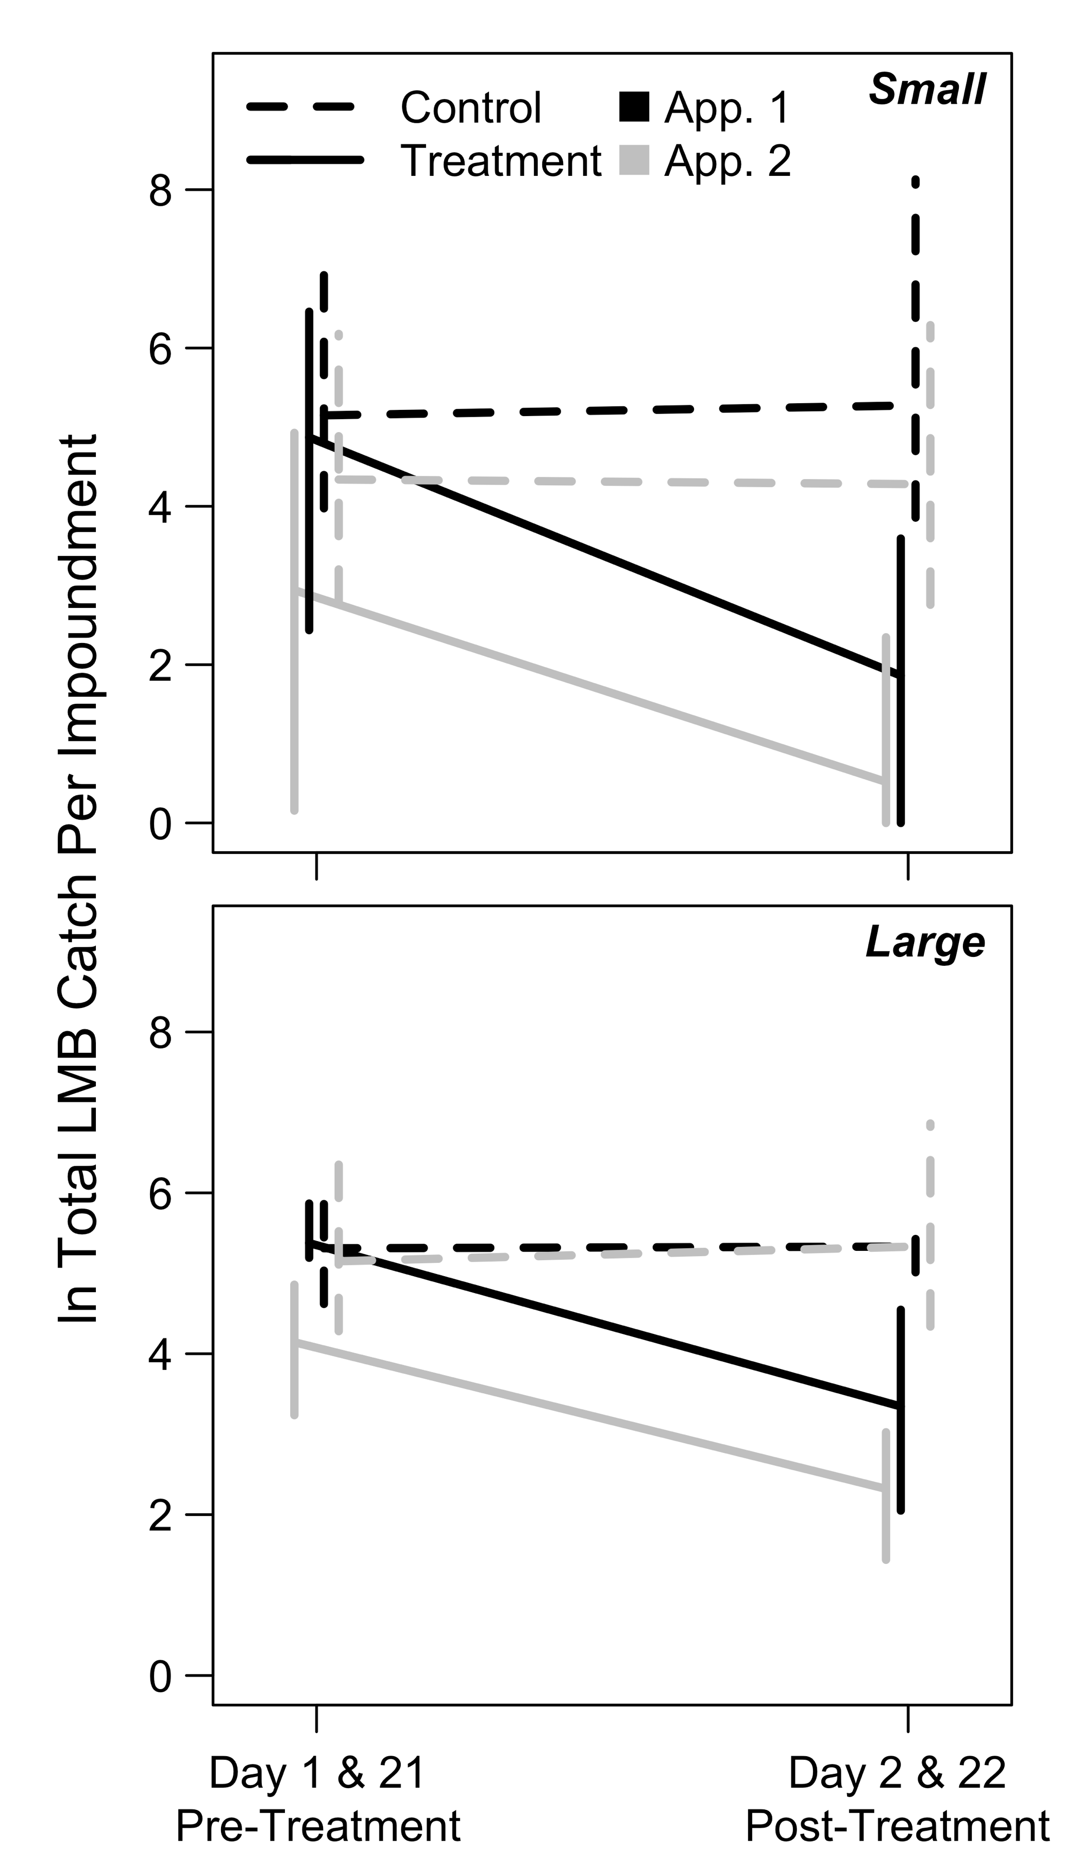

Figure 2.

Largemouth Bass loge total seine catches immediately before (days 1 and 21) and after (days 2 and 22) the first (“App. 1”; black lines) and second (“App. 2”; grey lines) shoreline rotenone applications in small (<12 ha; upper panel) and large (>33 ha; lower panel) impoundments. Solid lines denote treated impoundments and dashed lines denote controls. Observations were pooled across years (2017 and 2018) and error bars represent the 2.5th and 97.5th percentiles (95% confidence intervals).

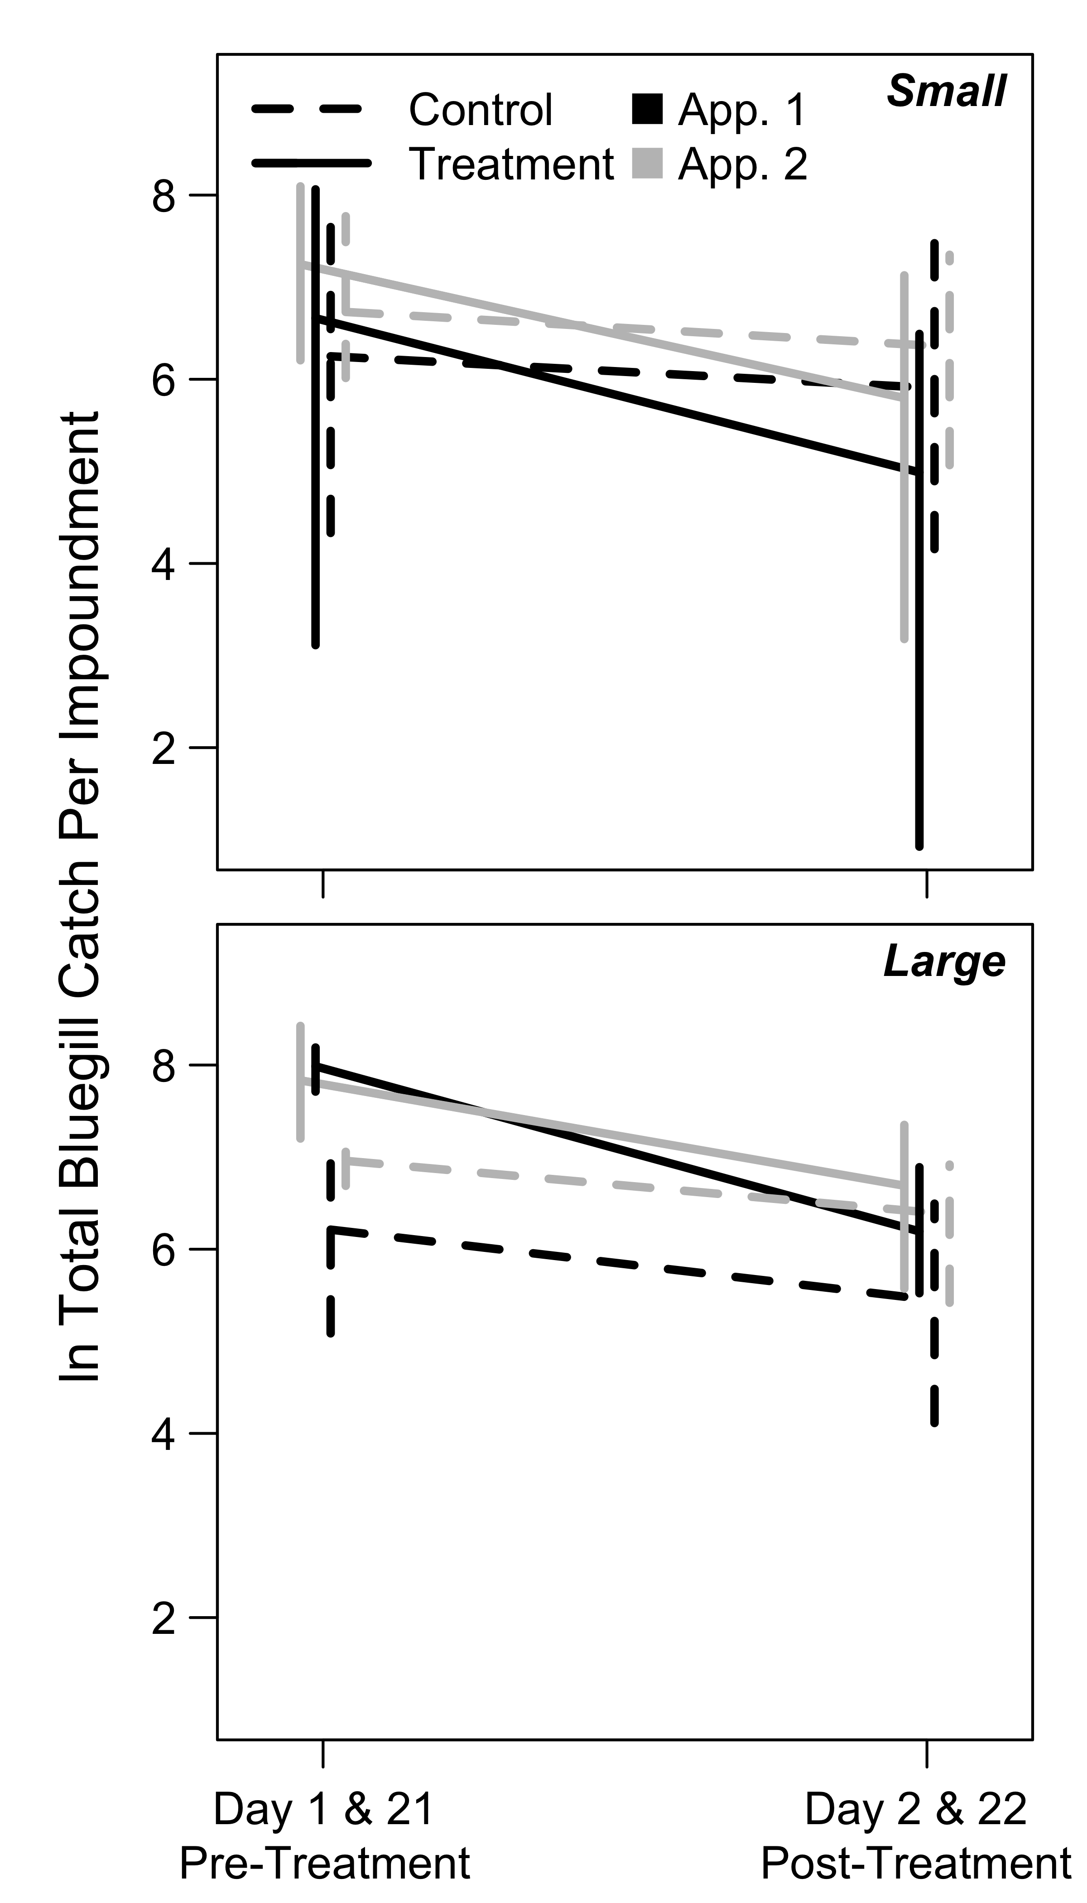

Figure 3.

Bluegill loge total seine catches immediately before (days 1 and 21) and after (days 2 and 22) the first (“App. 1”; black lines) and second (“App. 2”; grey lines) shoreline rotenone applications in small (<12 ha; upper panel) and large (>33 ha; lower panel) impoundments. Data are presented as in Figure 2.

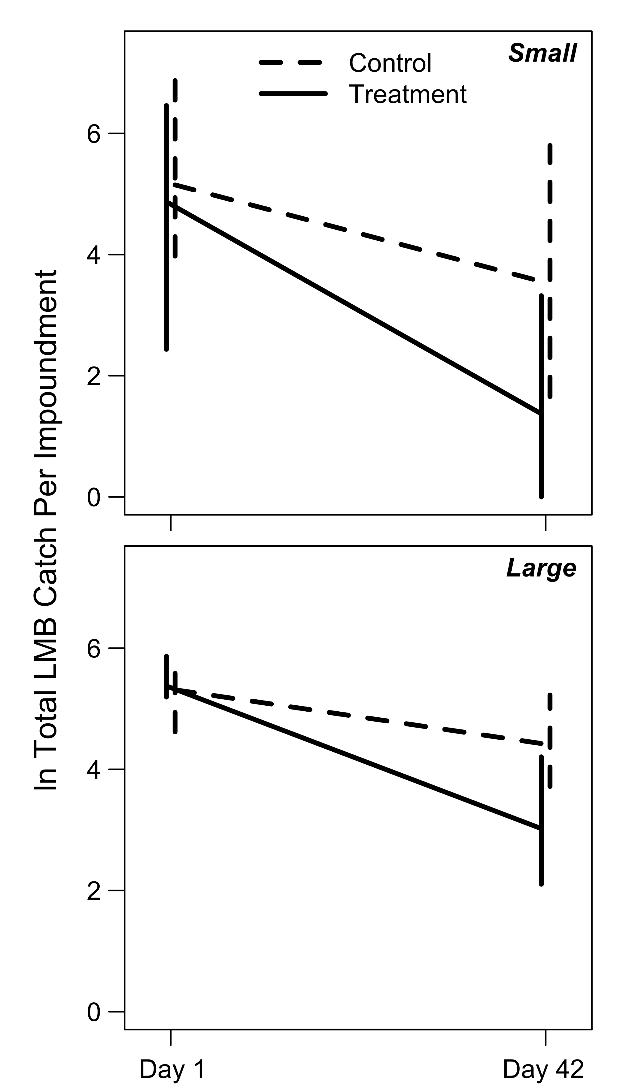

Figure 4.

Largemouth Bass loge total seine catches in small (<12 ha; upper panel) and large (>33 ha; lower panel) impoundments immediately before rotenone application (day 1) and at mid-summer after both rotenone applications (day 42). Solid lines denote impoundments that received shoreline rotenone treatments, and dashed lines denote controls. Data were pooled across years (2017, 2018) and error bars represent 95% confidence intervals.

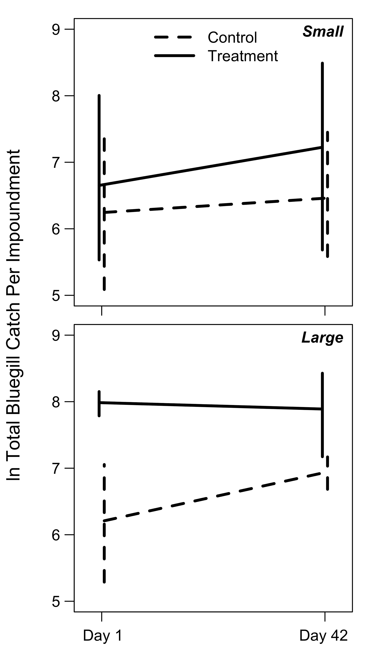

Figure 5.

Bluegill loge total seine catches in small (<12 ha; upper panel) and large (>33 ha; lower panel) impoundments immediately before rotenone application (day 1) and at mid-summer after both rotenone applications (day 42). Data are presented as in Figure 4.

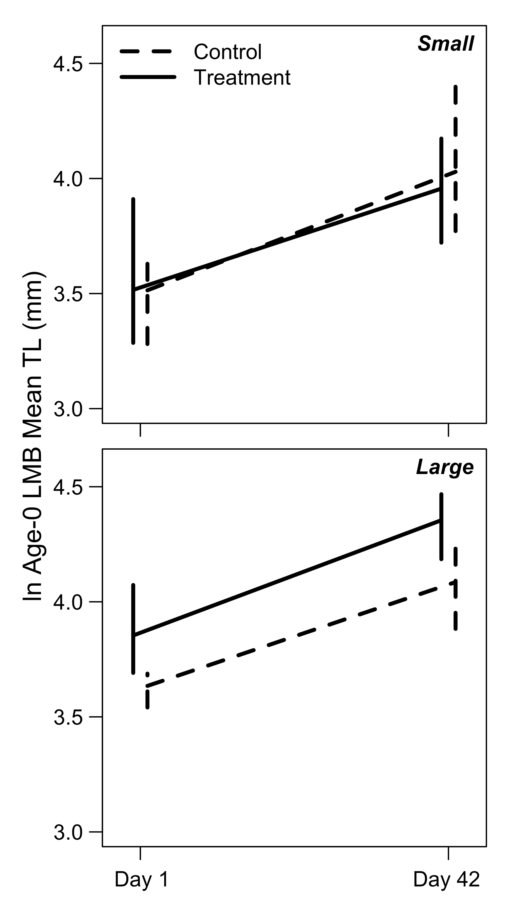

Figure 6.

Largemouth Bass loge MLA-0 in small (<12 ha; upper panel) and large (>33 ha; lower panel) impoundments immediately before rotenone application (day 1) and at mid-summer after both rotenone applications (day 42). Data are presented as in Figure 4.

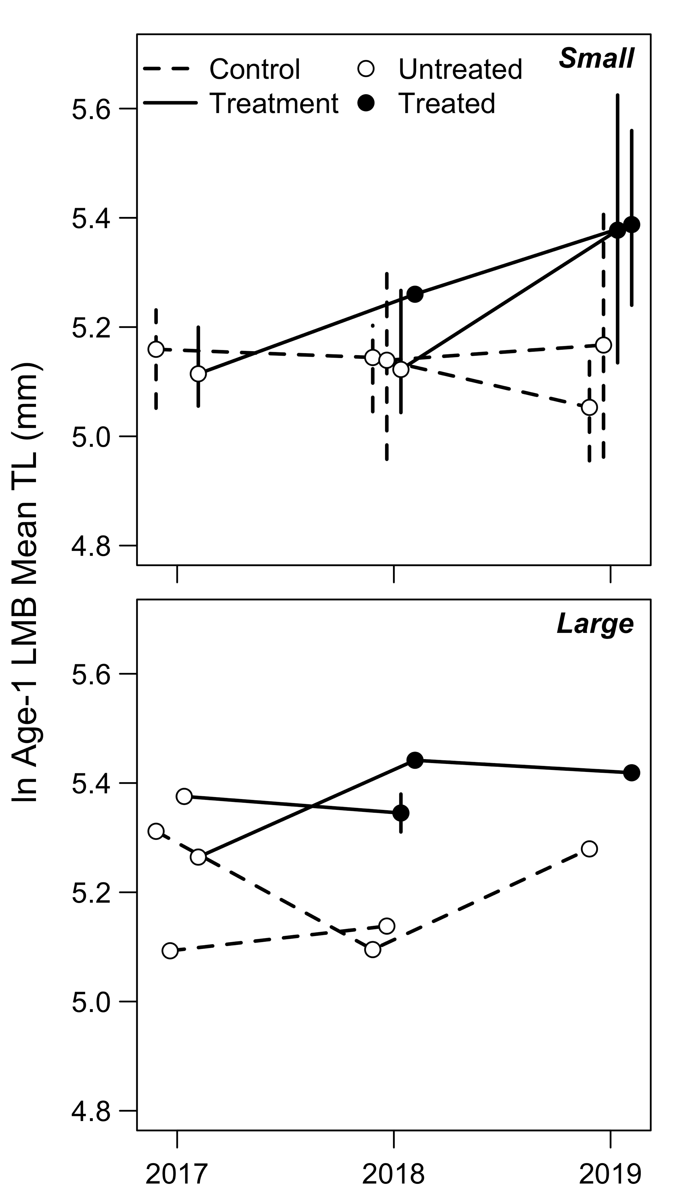

Figure 7.

Temporal trends in Largemouth Bass loge MLA-1 in small (<12 ha; upper panel) and large (>33 ha; lower panel) impoundments in control (dashed lines) and treatment (solid lines) impoundments. Open circles denote untreated impoundments, while closed circles denote treated impoundments. Solid lines leading from a closed circle to another closed circle represent the impoundments that were treated twice (e.g., see Table 1). Times treated (untreated control, once, twice) was the variable of interest in our model, and this portrays how the model compared those different levels of treatment. Error bars represent the 95% confidence intervals of the data when the sample size for that year was greater than two impoundments.

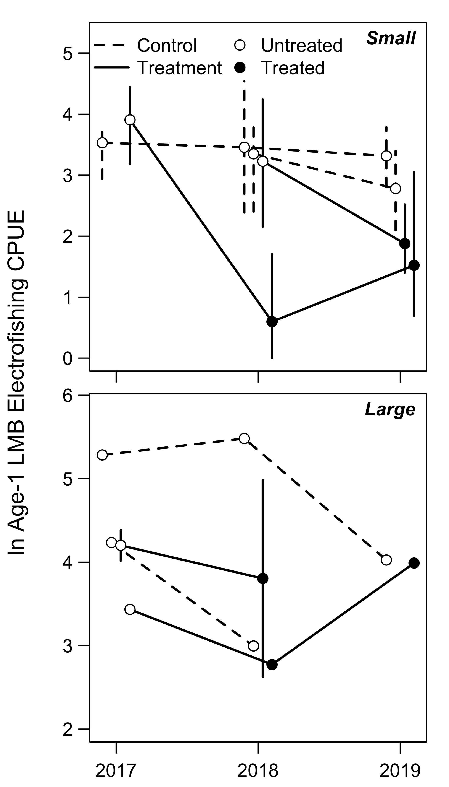

Figure 8.

Temporal trends in age-1 Largemouth Bass loge electrofishing CPUE (fish caught per 30 minutes electrofishing)—as a proxy for recruitment—in small (<12 ha; upper panel) and large (>33 ha; lower panel), and control (dashed lines) and treatment (solid lines) impoundments. Open circles denote untreated impoundments, while closed circles denote treated impoundments. Data are presented as in Figure 7.

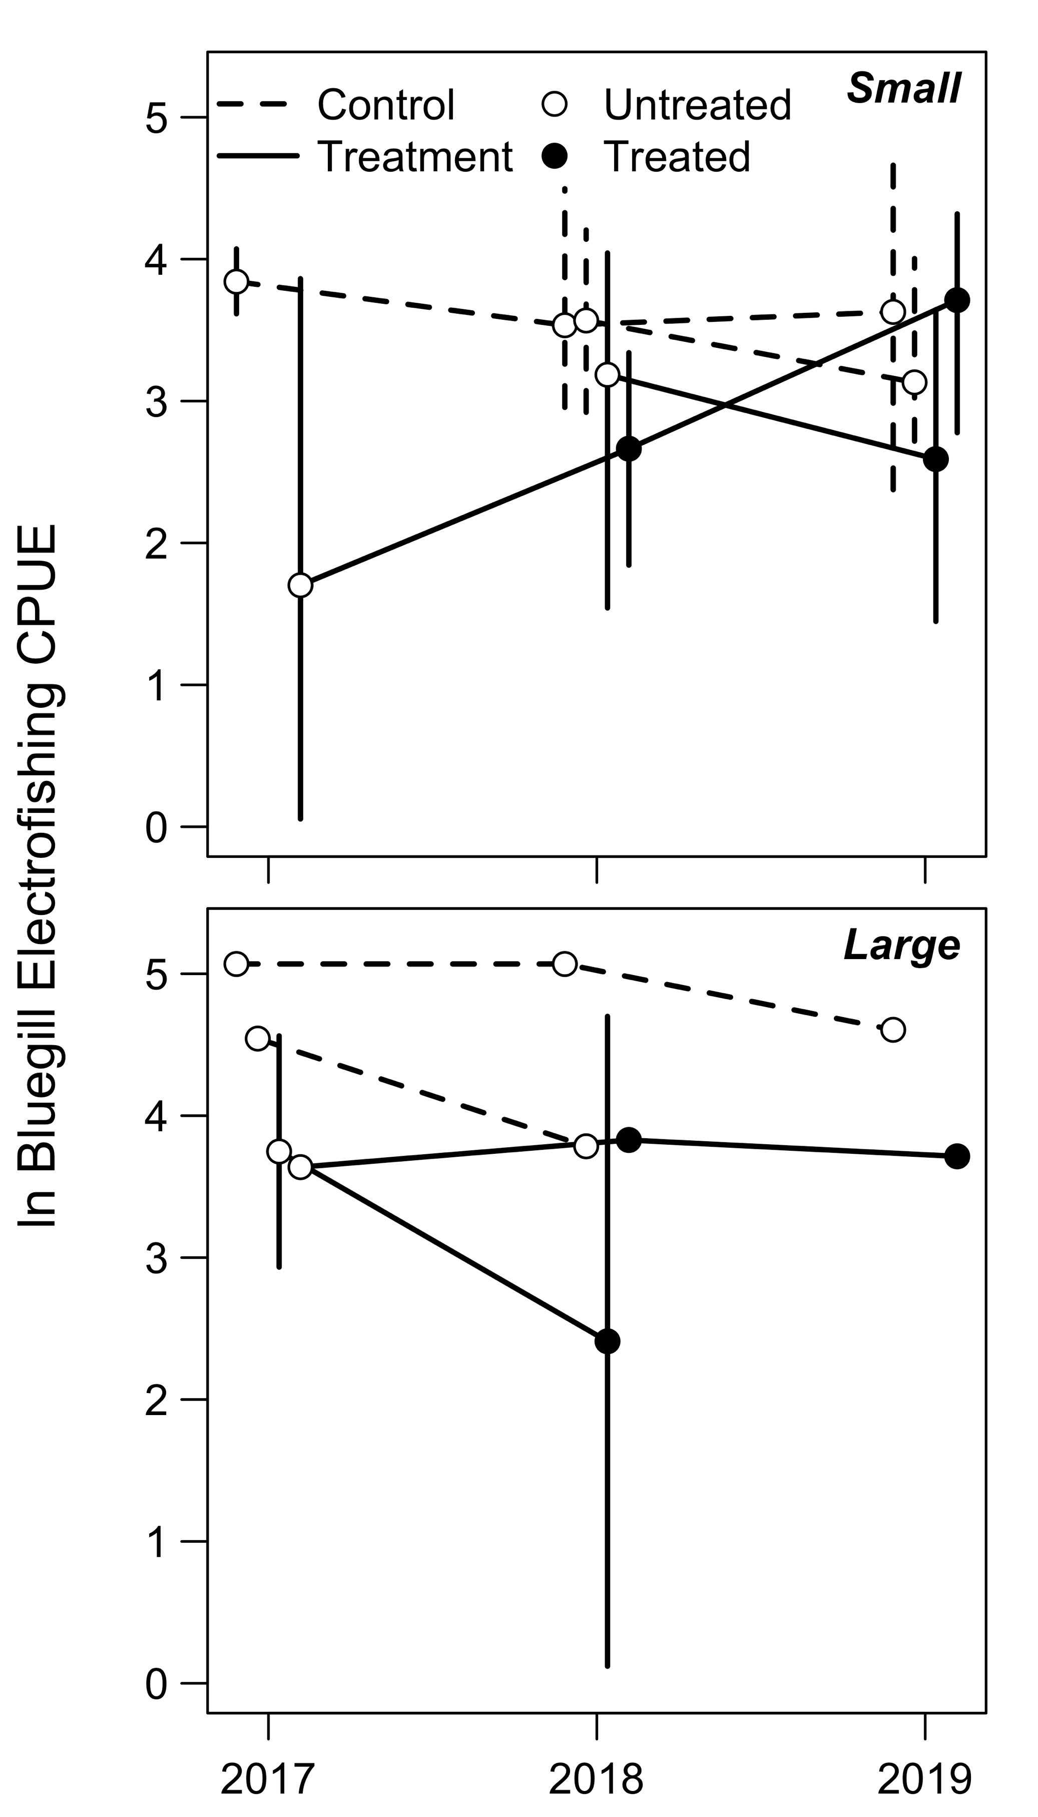

Figure 9.

Temporal trends in Bluegill (>80 mm) loge electrofishing CPUE (fish caught per 30 minutes electrofishing) in small (<12 ha; upper panel) and large (>33 ha; lower panel), and control (dashed lines) and treatment (solid lines) impoundments. Open circles denote untreated impoundments, while closed circles denote treated impoundments. Data are presented as in Figure 7.